TRIBHUVAN UNIVERSITY
PATAN MULTIPLE CAMPUS
PATANDHOKA, LALITPUR

DATABASE ADMINISTRATION (BIT 352)

SUBMITTED BY: | SUBMITTED TO:
NAME: SURESH DAHAL | BIPIN TIMALSINA
ROLL: 23
CLASS: BIT-III/II | ___________________
DATE: 2083/04/22 | CHECKED BY

11. Working With RMAN Backup and Recovery
THEORY:
Recovery Manager (RMAN) is Oracle's built-in utility used to perform database backup, restore, and recovery operations. RMAN provides block-level corruption detection, backup optimization, and automatic recovery using archived redo logs.
For online backup and complete recovery, the database should be in ARCHIVELOG mode. RMAN can back up the entire database, archived redo logs, control files, and SPFILE. In case of data loss, RMAN restores the required files from backup and applies archived redo logs to recover the database to the latest consistent state.
STEPS AND COMMANDS
a) Preparation and Configuration for Backup
Step 1: Connect as SYSDBA
CONNECT / AS SYSDBA;

Step 2: Check whether the database is in ARCHIVELOG mode
ARCHIVE LOG LIST;
or
SELECT LOG_MODE FROM V$DATABASE;

Step 3: Enable ARCHIVELOG mode (if required)
SHUTDOWN IMMEDIATE;

STARTUP MOUNT;

ALTER DATABASE ARCHIVELOG;

ALTER DATABASE OPEN;

Step 4: Check Fast Recovery Area (FRA)
SHOW PARAMETER db_recovery_file_dest;

SHOW PARAMETER db_recovery_file_dest_size;
If not configured,
ALTER SYSTEM SET db_recovery_file_dest='D:\Oracle\FRA' SCOPE=BOTH;

ALTER SYSTEM SET db_recovery_file_dest_size=10G SCOPE=BOTH;

Step 5: Connect to RMAN
rman target /

Step 6: Display current RMAN configuration
SHOW ALL;

Step 7: Enable Control File Autobackup
CONFIGURE CONTROLFILE AUTOBACKUP ON;
Verify:
SHOW ALL;

b) Perform Full Backup
Step 1: Backup the entire database including archived redo logs
BACKUP DATABASE PLUS ARCHIVELOG;

Step 2: Verify backup
LIST BACKUP;

c) Simulate Database Failure
Step 1: Find the USERS datafile
SELECT FILE#, NAME
FROM V$DATAFILE;

Step 2: Shutdown database
SHUTDOWN IMMEDIATE;

Step 3: Delete the USERS datafile
Windows
del D:\Oracle\oradata\ORCL\users01.dbf
Linux
rm users01.dbf

Step 4: Switch to OCRLPDB and open database
alter session set container = orclpdb
alter database open
Oracle should display an error similar to:
ORA-01157
ORA-01110

d) Restore and Recover the Datafile
Step 1: Connect to RMAN
rman target /

Step 2: Restore the datafile
RESTORE DATAFILE 14;

Step 3: Recover the datafile
RECOVER DATAFILE 14;

Step 5: Verify
SELECT FILE#, STATUS
FROM V$DATAFILE
WHERE FILE#=14;

e) Full Database Recovery Simulation
Step 1: Shutdown database
SHUTDOWN IMMEDIATE;

Step 2: Delete the SPFILE, control files and datafiles
(Delete them using your operating system.)

Step 3: Connect RMAN
rman target /

Step 4: Restore SPFILE
STARTUP FORCE NOMOUNT;

RESTORE SPFILE FROM AUTOBACKUP;

Step 5: Restore control file
RESTORE CONTROLFILE FROM AUTOBACKUP;

Step 6: Restore database
RESTORE DATABASE;

Step 7: Recover database
RECOVER DATABASE;

Step 8: Open database
ALTER DATABASE OPEN RESETLOGS;

f) Validation and Cleanup
Step 1: Validate database
VALIDATE DATABASE;

Step 2: Check corruption
SELECT *
FROM V$DATABASE_BLOCK_CORRUPTION;

Step 3: Verify data
SELECT username FROM dba_users;

OUTPUT
a) Preparation and Configuration for Backup
Step 1: Connect as SYSDBA
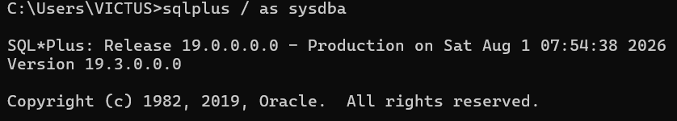
Step 2: Check whether the database is in ARCHIVELOG mode
or
Step 3: Enable ARCHIVELOG mode
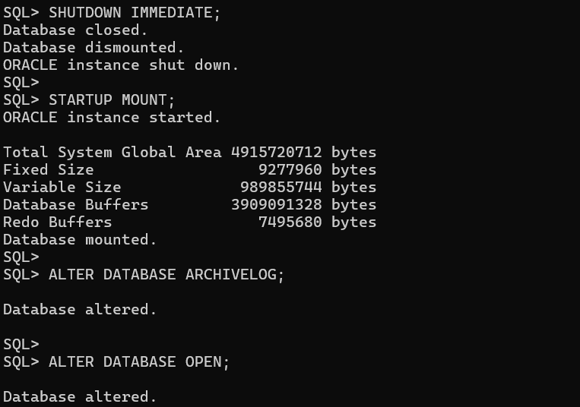
Step 4: Check Fast Recovery Area (FRA)
Step 5: Connect to RMAN
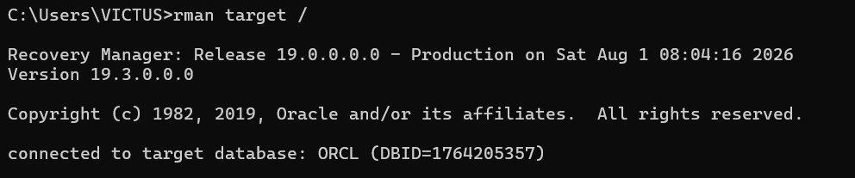Step 6: Display current RMAN configuration
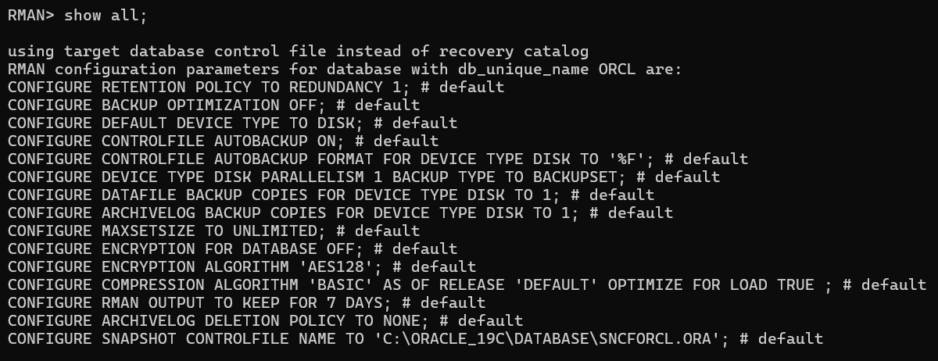Step 7: Enable Control File Autobackup
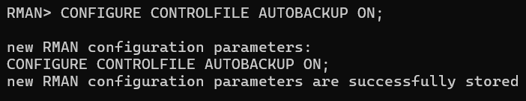
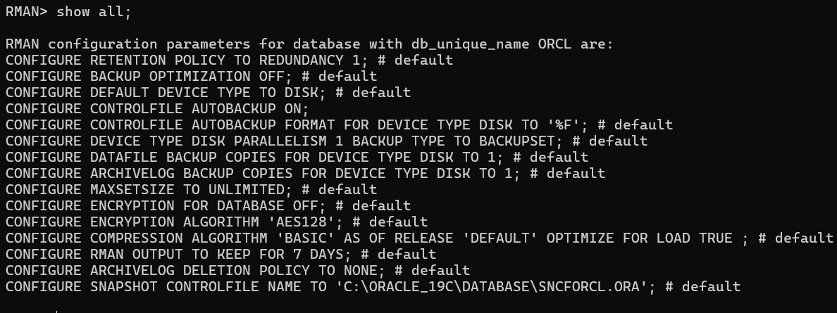
b) Perform Full Backup
Step 1: Backup the entire database including archived redo logs
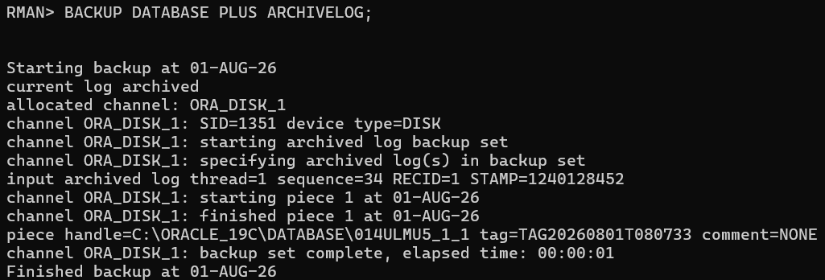
Step 2: Verify backup
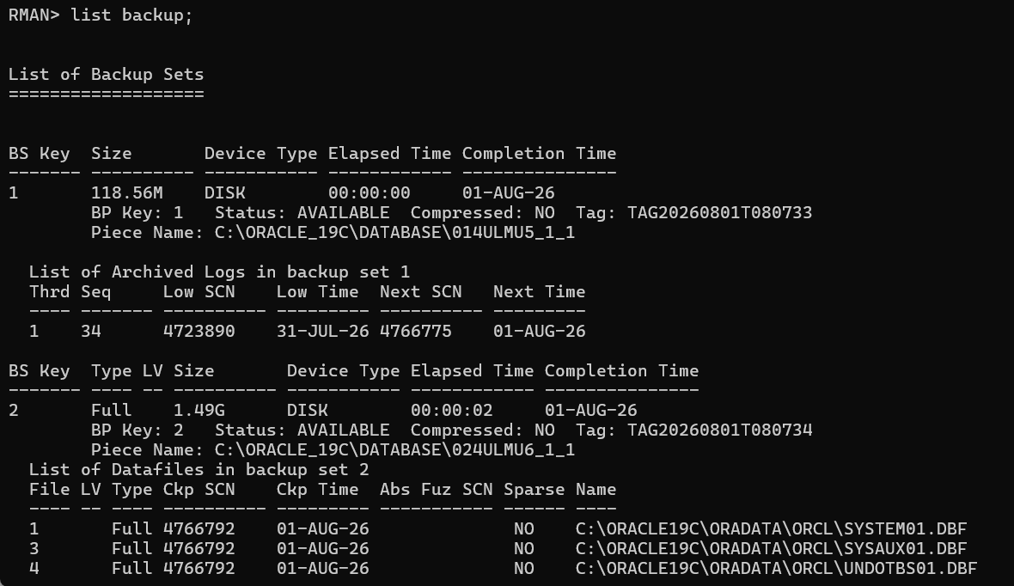
c) Simulate Database Failure
Step 1: Find the USERS datafile
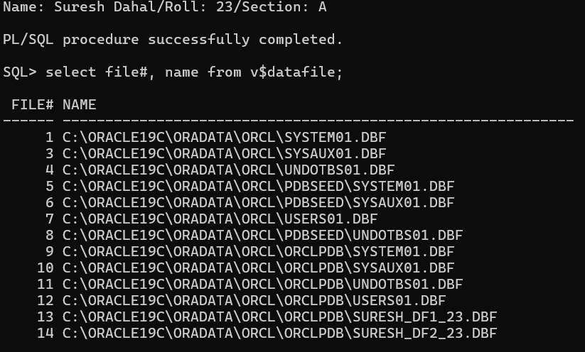
Step 2: Shutdown database
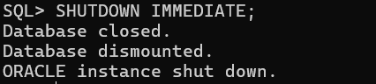
Step 3: Delete the USERS datafile
Step 4: Switch to OCRLPDB and open database
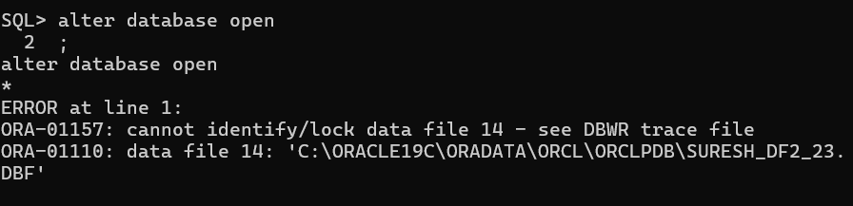
d) Restore and Recover the Datafile
Step 1: Connect to RMAN
rman target /
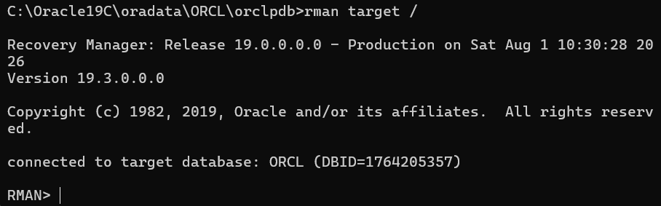
Step 2: Restore the datafile
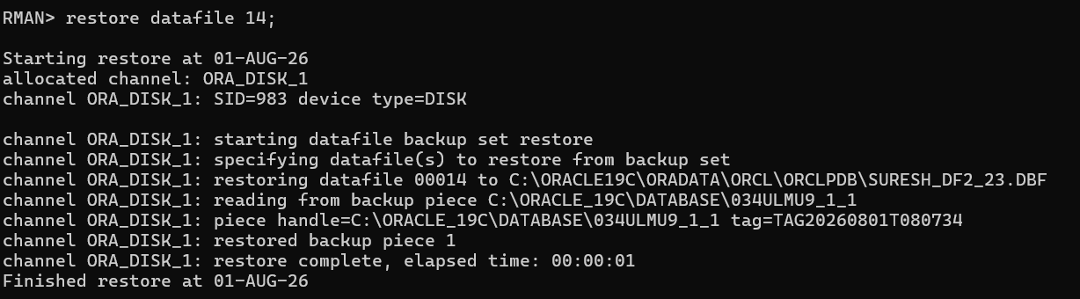
Step 3: Recover the datafile
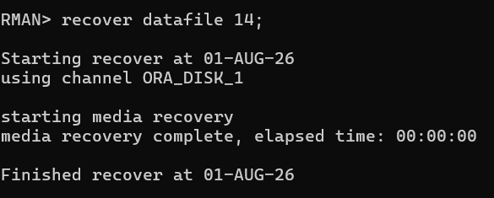
Step 4: Verify
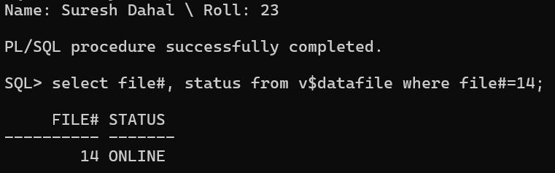

e) Full Database Recovery Simulation
Step 1: Shutdown database
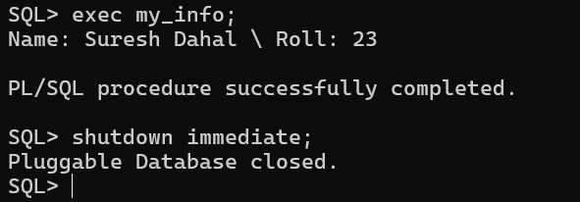
Step 2: Delete the SPFILE, control files and datafiles
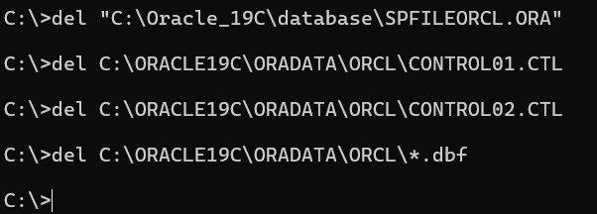
Step 3: Connect RMAN
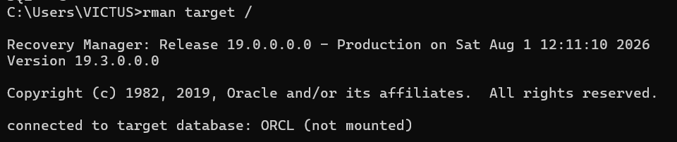
Step 4: Restore SPFILE
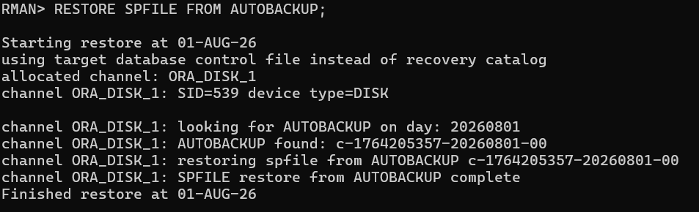

Step 5: Restore control file
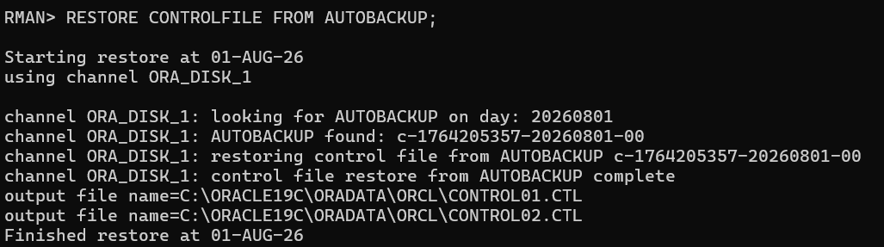
Step 6: Restore database
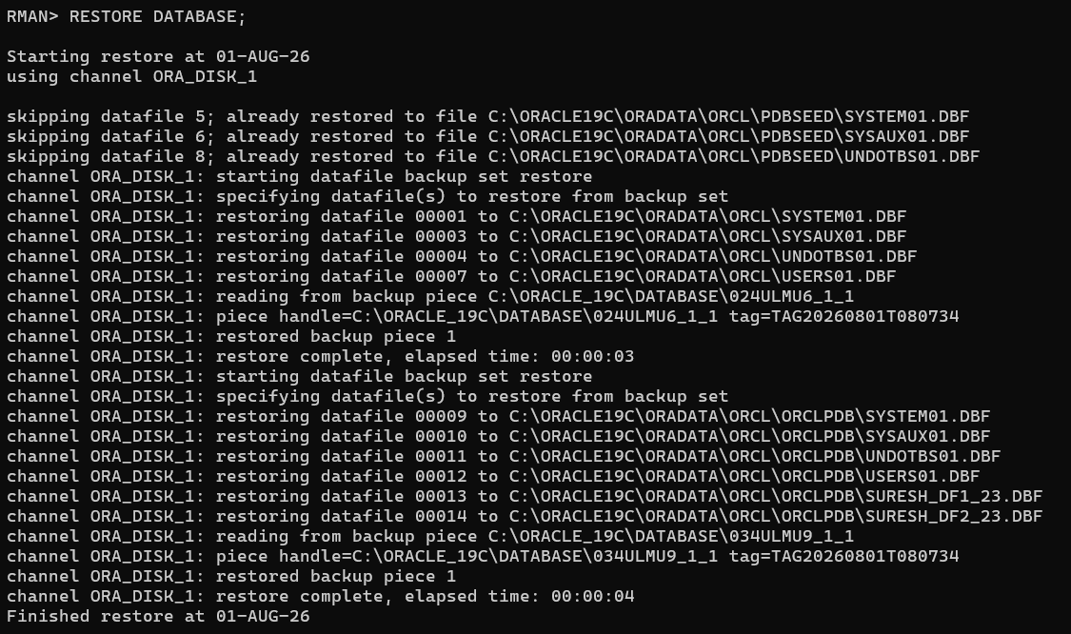Step 7: Recover database
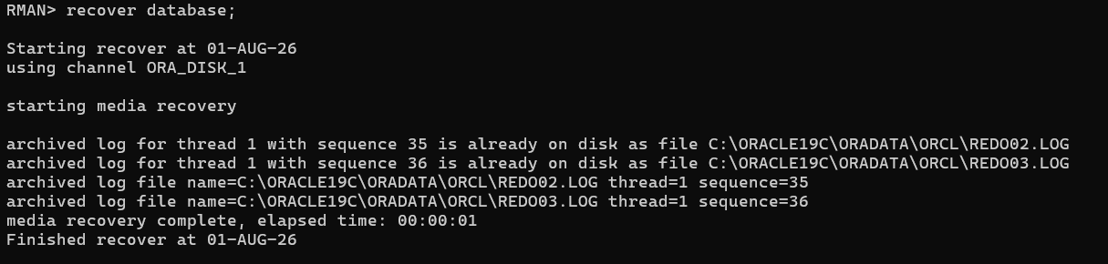
Step 8: Open database
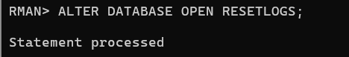
f) Validation and Cleanup
Step 1: Validate database
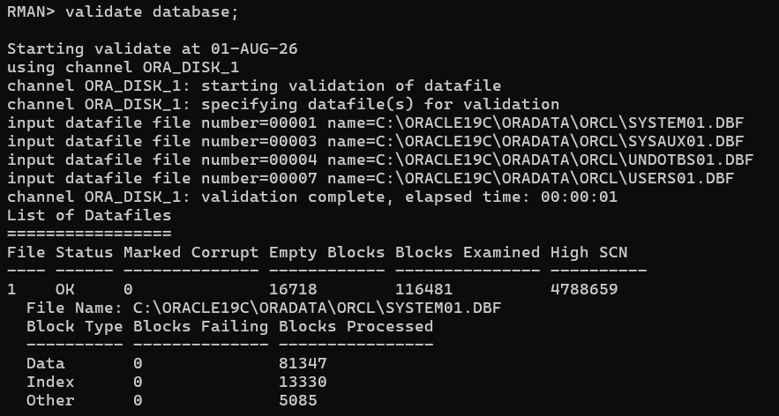Step 2: Check corruption
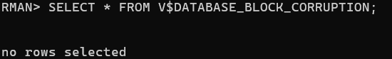
Step 3: Verify data
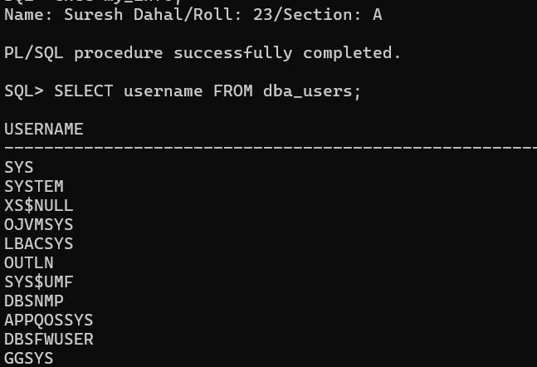

12. LEARNING ABOUT STANDARD AUDITING IN ORACLE
THEORY
Standard Auditing in Oracle is a security feature used to monitor and record database activities performed by users. It helps database administrators track operations such as SELECT, INSERT, UPDATE, and DELETE on database objects. Audit records are stored in the database when the AUDIT_TRAIL initialization parameter is enabled. When configured as DB, audit records are stored in database tables, whereas DB, EXTENDED additionally stores the SQL statements executed. Standard auditing is commonly used to monitor user activities, improve database security, maintain accountability, and assist in compliance with organizational security policies.
STEPS and COMMANDS
(a) Preparation and Configuration for Standard Auditing
CONNECT / AS SYSDBA;

ALTER SESSION SET CONTAINER = ORCLPDB;

SHOW PARAMETER audit_trail;

(b) Enable Auditing
AUDIT SELECT, INSERT, UPDATE, DELETE
ON HR.EMPLOYEES
BY ACCESS;

(c) Generate Audit Records
CONNECT Hr/thaxaena@ORCLPDB;

SELECT first_name, email, salary
FROM EMPLOYEES
WHERE EMPLOYEE_ID = 100;

UPDATE EMPLOYEES
SET SALARY = SALARY + 100
WHERE EMPLOYEE_ID = 100;

COMMIT;

(d) Query and Analyze Audit Trail
CONNECT / AS SYSDBA;

ALTER SESSION SET CONTAINER = ORCLPDB;

SELECT username,
action_name,
obj_name,
timestamp,
sql_text
FROM dba_audit_trail
WHERE username='HR'
AND obj_name='EMPLOYEES'
ORDER BY timestamp DESC;
Column Description
- USERNAME – User who performed the action.
- ACTION_NAME – Type of SQL operation performed.
- OBJ_NAME – Name of the database object.
- TIMESTAMP – Date and time of execution.
- SQL_TEXT – SQL statement executed (available with DB, EXTENDED).

(e) Disable Auditing and Purge Audit Trail
NOAUDIT SELECT, INSERT, UPDATE, DELETE
ON HR.EMPLOYEES;
BEGIN
DBMS_AUDIT_MGMT.INIT_CLEANUP(
AUDIT_TRAIL_TYPE => DBMS_AUDIT_MGMT.AUDIT_TRAIL_AUD_STD,
DEFAULT_CLEANUP_INTERVAL => 24);
END;
/
BEGIN
DBMS_AUDIT_MGMT.CLEAN_AUDIT_TRAIL(
AUDIT_TRAIL_TYPE => DBMS_AUDIT_MGMT.AUDIT_TRAIL_AUD_STD,
USE_LAST_ARCH_TIMESTAMP => FALSE);
END;
/

(f) Validation
CONNECT Hr/thaxaena@orclpdb;

SELECT first_name, email, salary
FROM EMPLOYEES
WHERE EMPLOYEE_ID = 100;
CONNECT / AS SYSDBA;

ALTER SESSION SET CONTAINER = ORCLPDB;

SELECT username,
action_name,
obj_name,
timestamp
FROM dba_audit_trail
WHERE username='HR'
AND obj_name='EMPLOYEES'
ORDER BY timestamp DESC;

OUTPUT
(a) Preparation and Configuration for Standard Auditing
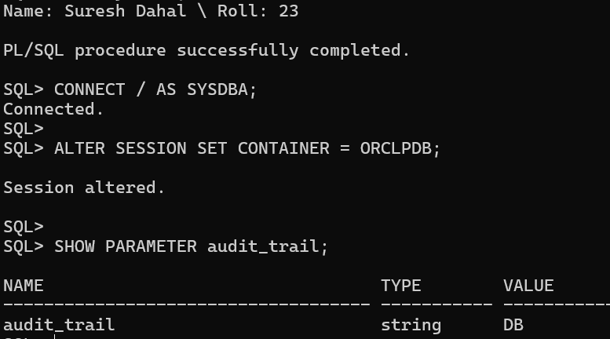
(b) Enable Auditing
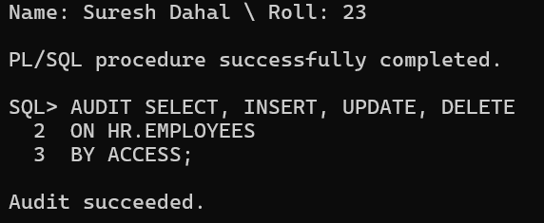
(c) Generate Audit Records
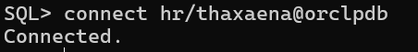
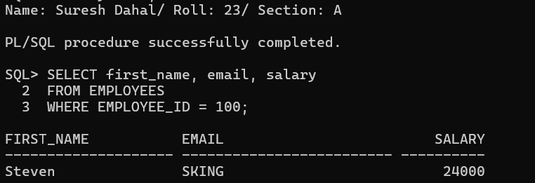
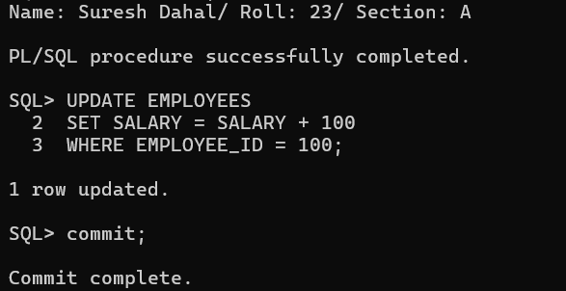

(d) Query and Analyze Audit Trail
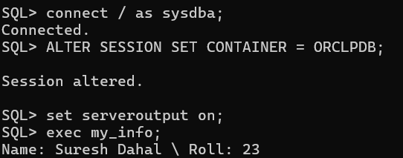
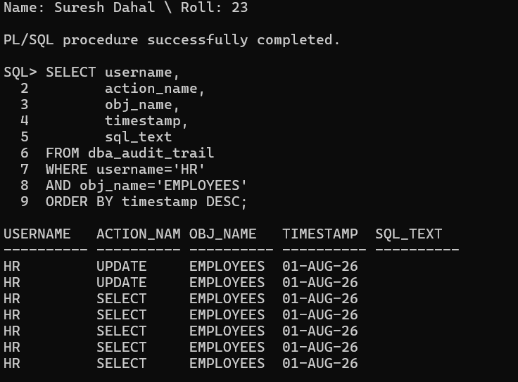
(e) Disable Auditing and Purge Audit Trail
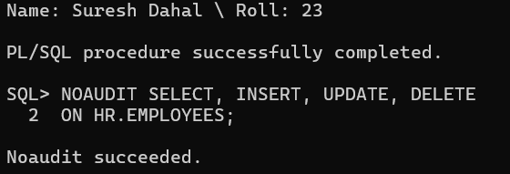
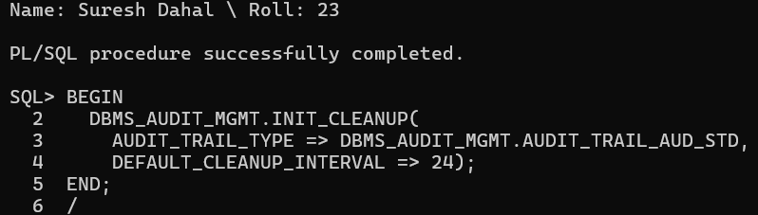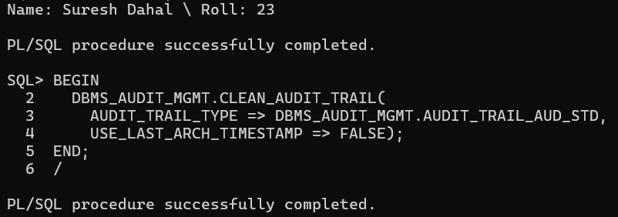
(f) Validation
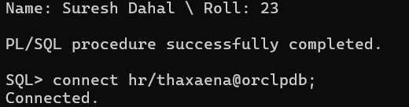
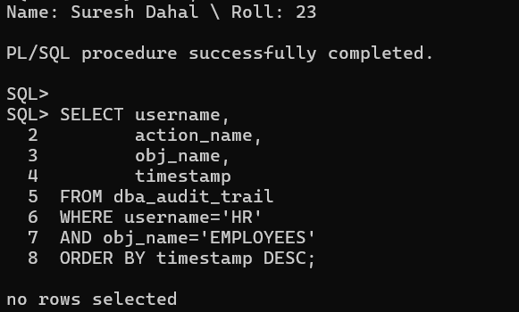

13. WORKING WITH UNIFIED AUDITING IN ORACLE
THEORY
Unified Auditing is Oracle's modern auditing framework that consolidates audit records from different sources into a single audit trail. It provides centralized monitoring of user activities, database operations, and security-related events. Audit policies are created to specify which actions should be monitored and can be enabled or disabled as needed. Audit records are stored in the UNIFIED_AUDIT_TRAIL view, allowing database administrators to analyze user activities, improve security, and meet compliance requirements.

STEPS and COMMANDS
(a) Preparation and Verification
Connect as SYS:
CONNECT / AS SYSDBA;
Switch to the PDB if using Oracle Multitenant:
ALTER SESSION SET CONTAINER = ORCLPDB;
Verify Unified Auditing:
SELECT parameter, value
FROM v$option
WHERE parameter = 'Unified Auditing';
If the value is FALSE, mention it in the report. Oracle 19c mixed mode still allows Unified Auditing.

(b) Create and Enable Audit Policy
Create the audit policy:
CREATE AUDIT POLICY hr_emp_policy
ACTIONS
SELECT ON HR.EMPLOYEES,
INSERT ON HR.EMPLOYEES,
UPDATE ON HR.EMPLOYEES,
DELETE ON HR.EMPLOYEES;
Enable the policy:
AUDIT POLICY hr_emp_policy;

(c) Generate Audit Records
Connect as HR:
CONNECT Hr/thaxaena;
Insert a record:
INSERT INTO employees
(employee_id, first_name, last_name, email, hire_date, job_id, salary)

VALUES
(999,
'Test',
'User',
'test@example.com',
SYSDATE,
'IT_PROG',
5000);

COMMIT;
Delete the record:
DELETE FROM employees
WHERE employee_id = 999;

COMMIT;

(d) Query and Analyze Unified Audit Trail
Connect as SYS:
CONNECT / AS SYSDBA;
Switch to the PDB:
ALTER SESSION SET CONTAINER = ORCLPDB;
Query the audit trail:
SELECT
dbusername,
action_name,
object_schema,
object_name,
event_timestamp,
sql_text
FROM unified_audit_trail
WHERE dbusername='HR'
AND object_name='EMPLOYEES'
ORDER BY event_timestamp DESC;
Explanation of Columns
- DBUSERNAME – Database user who performed the action.
- ACTION_NAME – Type of SQL operation (INSERT, DELETE, UPDATE, SELECT).
- OBJECT_SCHEMA – Owner of the audited object.
- OBJECT_NAME – Name of the audited table.
- EVENT_TIMESTAMP – Date and time when the event occurred.
- SQL_TEXT – SQL statement that generated the audit record.

(e) Conditional Auditing
Create a conditional audit policy:
CREATE AUDIT POLICY hr_high_salary_pol
ACTIONS UPDATE ON HR.EMPLOYEES
WHEN 'NEW.SALARY > 10000'
EVALUATE PER STATEMENT;
Enable it:
AUDIT POLICY hr_high_salary_pol;
Connect as HR:
CONNECT Hr/thaxaena;
Execute a qualifying update:
UPDATE employees
SET salary = 12000
WHERE employee_id = 100;

COMMIT;
Verify the audit record:
CONNECT / AS SYSDBA;

ALTER SESSION SET CONTAINER = ORCLPDB;

SELECT
dbusername,
action_name,
event_timestamp,
sql_text
FROM unified_audit_trail
WHERE dbusername='HR'
ORDER BY event_timestamp DESC;

(f) Disable, Drop, and Cleanup
Disable both policies:
NOAUDIT POLICY hr_emp_policy;

NOAUDIT POLICY hr_high_salary_pol;
Drop them:
DROP AUDIT POLICY hr_emp_policy;

DROP AUDIT POLICY hr_high_salary_pol;
Purge the Unified Audit Trail:
BEGIN
DBMS_AUDIT_MGMT.CLEAN_AUDIT_TRAIL(
AUDIT_TRAIL_TYPE => DBMS_AUDIT_MGMT.AUDIT_TRAIL_UNIFIED,
USE_LAST_ARCH_TIMESTAMP => FALSE);
END;
/
Validation:
Connect as HR:
CONNECT Hr/thaxaena;

SELECT *
FROM employees
WHERE employee_id = 100;
Connect as SYS:
CONNECT / AS SYSDBA;

ALTER SESSION SET CONTAINER = ORCLPDB;

Fetch Data
SELECT
dbusername,
action_name,
object_name,
event_timestamp
FROM unified_audit_trail
WHERE dbusername='HR'
ORDER BY event_timestamp DESC;

OUTPUT
(a) Preparation and Verification
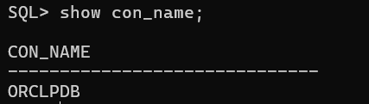
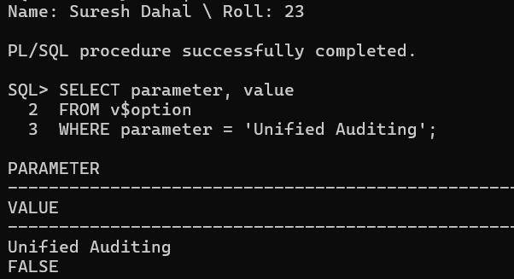
(b) Create and Enable Audit Policy
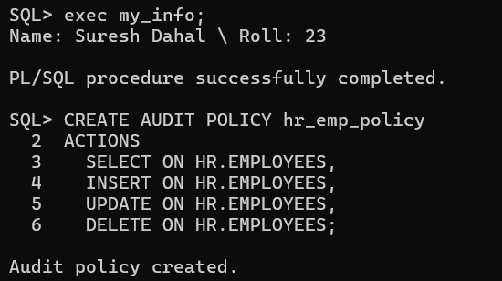
Enable the policy:
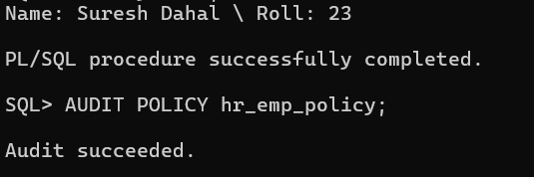
(c) Generate Audit Records
Connect as HR:
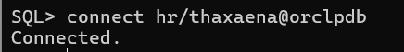
Insert a record:
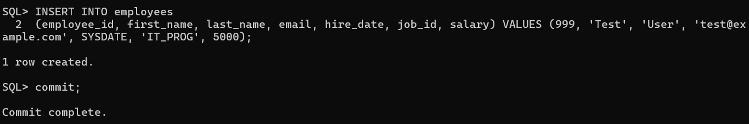
Delete the record:
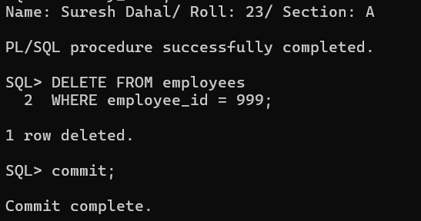

(d) Query and Analyze Unified Audit Trail
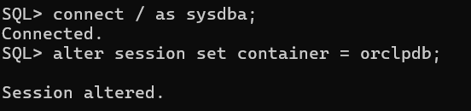
Query the audit trail:
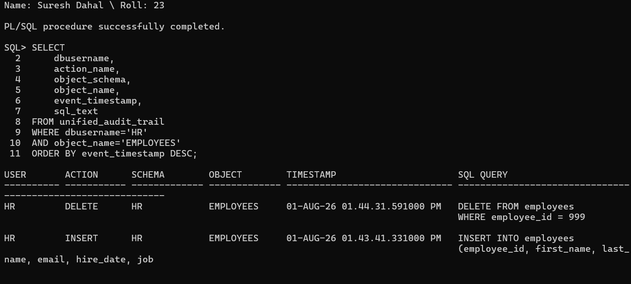

(e) Conditional Auditing
Create a conditional audit policy:
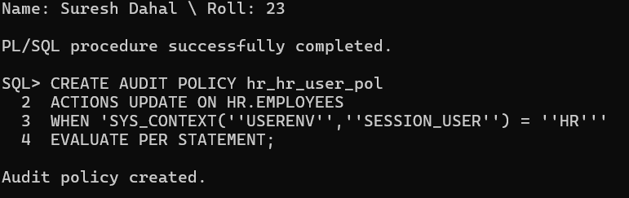Enable it:
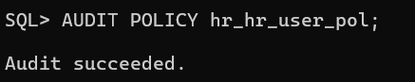
Connect as HR:
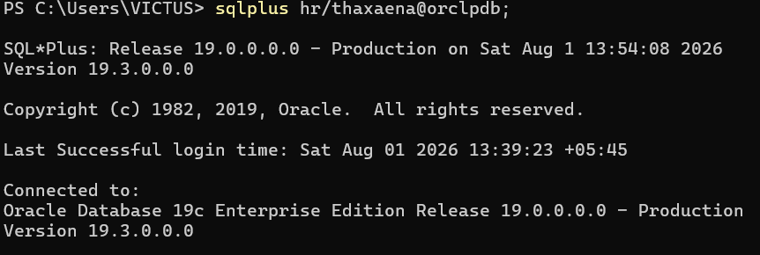Execute a qualifying update:
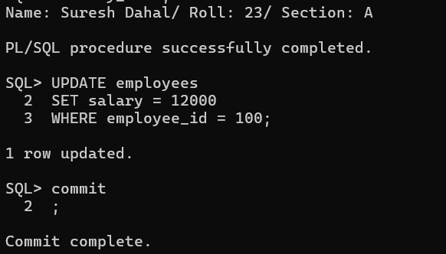
Verify the audit record:
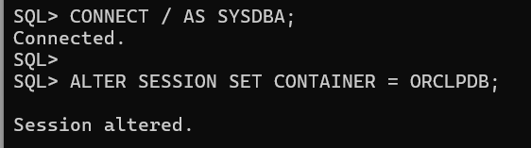
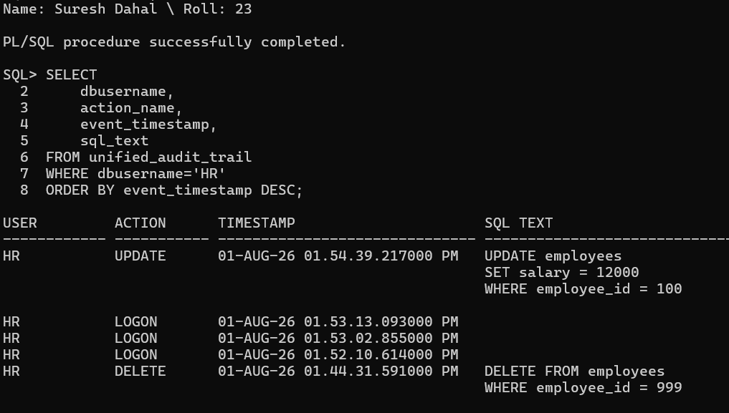
(f) Disable, Drop, and Cleanup
Disable both policies:
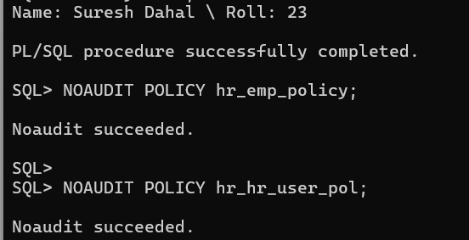
Drop them:
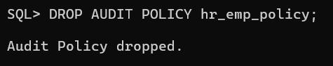
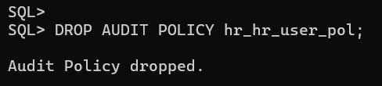
Purge the Unified Audit Trail:
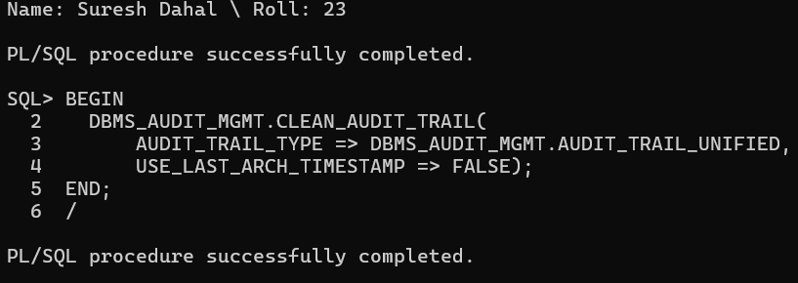
Validation:
Connect as HR:
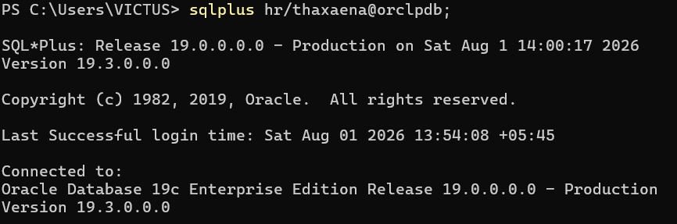
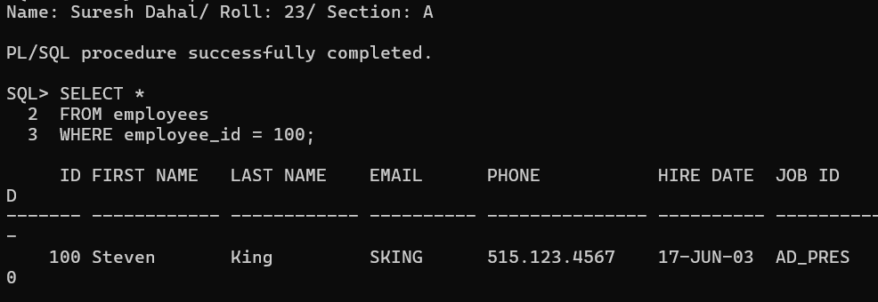
Connect as SYS:
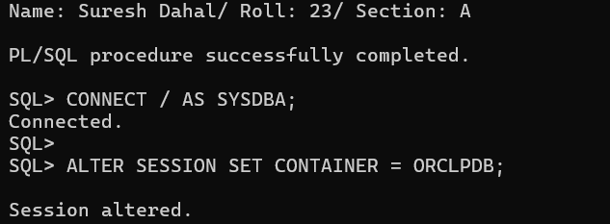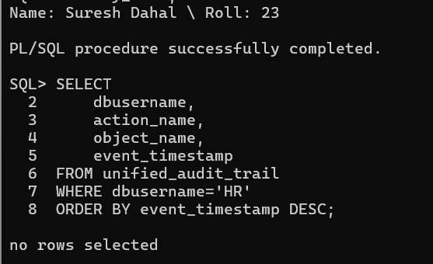

14. EXPLORING FLASHBACK TECHNOLOGY IN ORACLE.
THEORY
Oracle Flashback Technology is a collection of features that helps recover data from accidental changes without restoring backups. It allows users to view, recover, or restore previous versions of data using information stored in the UNDO tablespace and archived redo logs. Flashback operations are faster than traditional recovery methods because they work directly on database objects instead of restoring the entire database.
Flashback Query retrieves data as it existed at a specific point in time by using the AS OF TIMESTAMP or AS OF SCN clause.
Flashback Version Query displays all versions of a row that existed during a specified time interval. It also shows the type of operation (INSERT, UPDATE, DELETE) and when each version became valid.
Flashback Table restores an entire table to a previous point in time without affecting other database objects. The table must have ROW MOVEMENT enabled before performing this operation.
Flashback Drop recovers accidentally dropped tables from the Oracle Recycle Bin. Instead of permanently deleting a table, Oracle stores it in the recycle bin until it is purged.
UNDO_RETENTION specifies how long Oracle attempts to preserve undo information. Flashback Query and Flashback Version Query rely on this undo data to retrieve previous versions of rows.
ARCHIVELOG mode archives redo log files, allowing complete recovery and supporting many Flashback features. The Recycle Bin stores dropped tables temporarily so they can be restored using Flashback Drop.

STEPS and COMMANDS
(a) Preparation and Configuration
Step 1: Connect as SYS
sqlplus / as sysdba

Step 2: Check UNDO_RETENTION
SHOW PARAMETER undo_retention;

Step 3: Check Recycle Bin
SHOW PARAMETER recyclebin;
Step 4: Set UNDO_RETENTION
ALTER SYSTEM SET undo_retention=3600;

Step 5: Verify the change
SHOW PARAMETER undo_retention;

Step 6: Verify ARCHIVELOG mode
ARCHIVE LOG LIST;

(b) Flashback Query
Step 1: Connect as HR
CONNECT hr/thaxaena;

Step 2: Check current salary
SELECT employee_id,
first_name,
last_name,
salary
FROM employees
WHERE employee_id=103;
Record the salary.

Step 3: Record current timestamp
SELECT SYSTIMESTAMP FROM dual;
Record the timestamp.

Step 4: Increase salary
UPDATE employees
SET salary = salary + 1000
WHERE employee_id=103;

COMMIT;

Step 5: Verify updated salary
SELECT employee_id,salary
FROM employees
WHERE employee_id=103;

Step 6: Flashback Query
SELECT employee_id,
salary
FROM employees
AS OF TIMESTAMP
TO_TIMESTAMP(
'2026-08-01 07:31:44',
'YYYY-MM-DD HH24:MI:SS')
WHERE employee_id=103;

(c) Flashback Version Query
Step 1
Check salary.
SELECT employee_id,salary
FROM employees
WHERE employee_id=104;

Step 2
Increase salary by 500.
UPDATE employees
SET salary=salary+500
WHERE employee_id=104;

COMMIT;

Step 3
SELECT SYSTIMESTAMP FROM dual;

Step 4
Increase salary again.
UPDATE employees
SET salary=salary+600
WHERE employee_id=104;

COMMIT;

Step 5
Display all versions.
SELECT versions_starttime,
versions_endtime,
versions_operation,
salary
FROM employees
VERSIONS BETWEEN
TIMESTAMP
SYSTIMESTAMP-INTERVAL '10' MINUTE
AND SYSTIMESTAMP
WHERE employee_id=104;
Explanation
- VERSIONS_STARTTIME – Time when that row version became active.
- VERSIONS_ENDTIME – Time when the version stopped being active.
- VERSIONS_OPERATION – Database operation (I, U, D).
- SALARY – Salary value for that version.

(d) Flashback Table
Step 1
Connect as SYS.
CONNECT / AS SYSDBA;

Step 2
Enable row movement.
ALTER TABLE hr.employees
ENABLE ROW MOVEMENT;

Step 3
Connect back as HR.
CONNECT hr/thaxaena;

Step 4
Delete employee 105.
DELETE
FROM employees
WHERE employee_id=105;

COMMIT;

Step 5
Record timestamp.
SELECT SYSTIMESTAMP FROM dual;

Step 6
Flashback table.
FLASHBACK TABLE employees
TO TIMESTAMP
TO_TIMESTAMP(
'2026-08-01 07:43:08',
'YYYY-MM-DD HH24:MI:SS');

Step 7
Verify.
SELECT first_name
FROM employees
WHERE employee_id=105;

(e) Flashback Drop
Step 1
Drop table.
DROP TABLE locations CASCADE CONSTRAINTS;
Step 2
Check recycle bin.
SHOW RECYCLEBIN;
Step 3
Restore table.
FLASHBACK TABLE locations
TO BEFORE DROP;

Step 4
Verify.
SELECT *
FROM locations
WHERE location_id=1000;

(f) Validation and Cleanup
Restore employee 103 salary
UPDATE employees
SET salary=salary-1000
WHERE employee_id=103;

COMMIT;

Restore employee 104 salary
UPDATE employees
SET salary=salary-1100
WHERE employee_id=104;

COMMIT;

Delete employee 105 again
DELETE
FROM employees
WHERE employee_id=105;

COMMIT;

Demonstrating ORA-08180
SELECT first_name, last_name
FROM employees
AS OF TIMESTAMP
(SYSTIMESTAMP-INTERVAL '2' MONTH)
WHERE employee_id=103;
Explanation:
A Flashback Query was executed using a timestamp two months in the past. Oracle returned ORA-08180: no snapshot was found based on specified time because the required undo information was no longer available. This indicates that Oracle could not reconstruct the table's state for the specified time.

OUTPUT
(a) Preparation and Configuration
Step 1: Connect as SYS
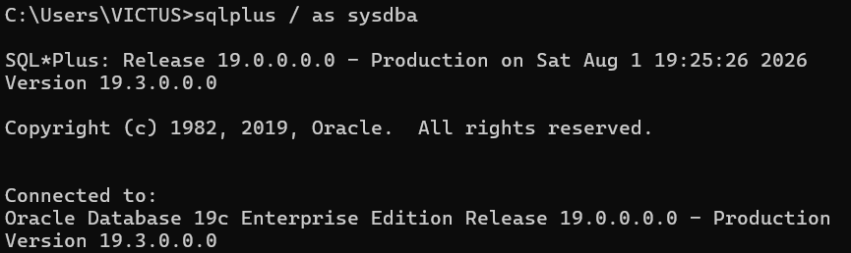
Step 2: Check UNDO_RETENTION
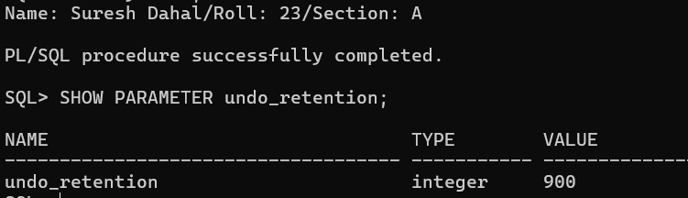
Step 3: Check Recycle Bin
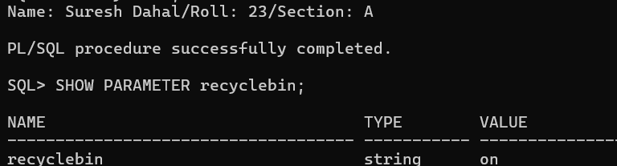
Step 4: Set UNDO_RETENTION (if less than 3600)
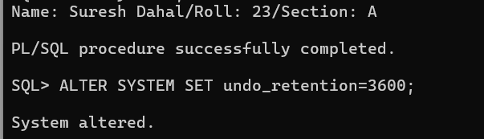
Step 5: Verify the change
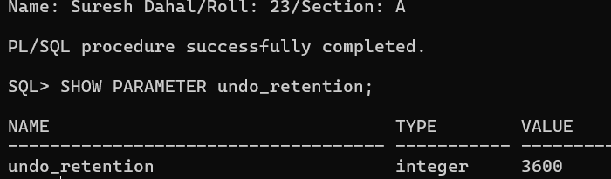
Step 6: Verify ARCHIVELOG mode
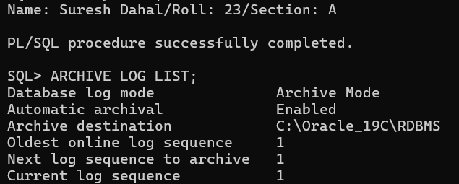
(b) Flashback Query
Step 1: Connect as HR
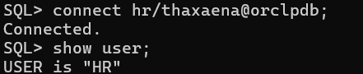
Step 2: Check current salary
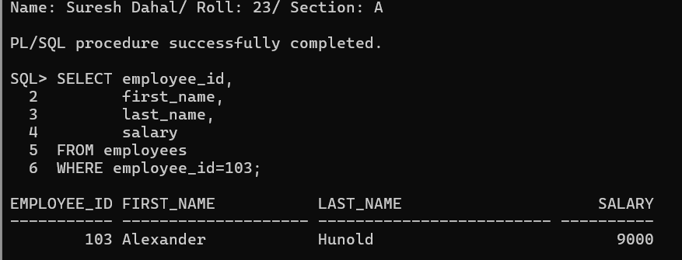

Step 3: Record current timestamp
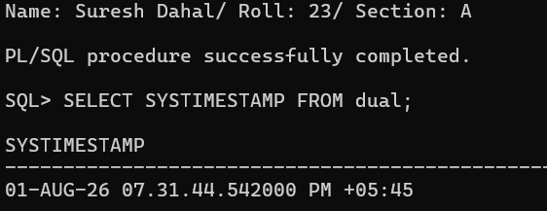

Step 4: Increase salary
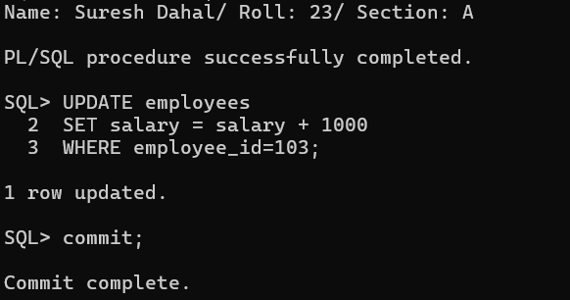

Step 5: Verify updated salary
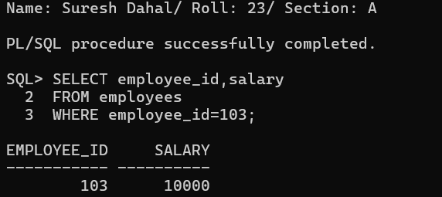
Step 6: Flashback Query
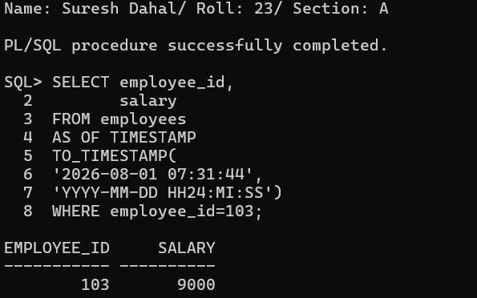

(c) Flashback Version Query
Step 1
Check salary.
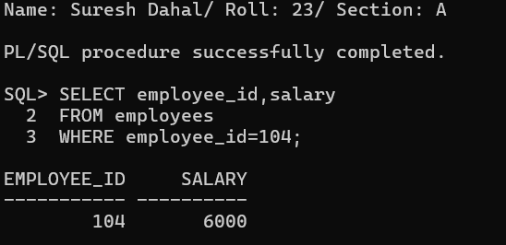

Step 2
Increase salary by 500.
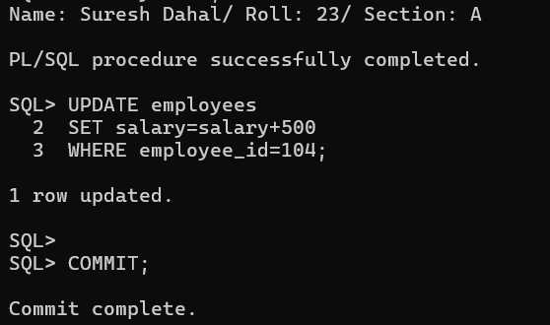
Step 3
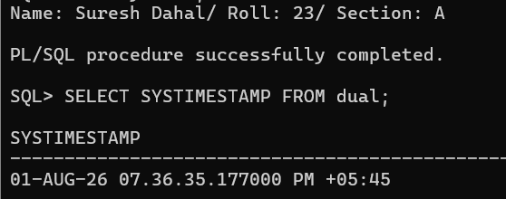
Step 4
Increase salary again.
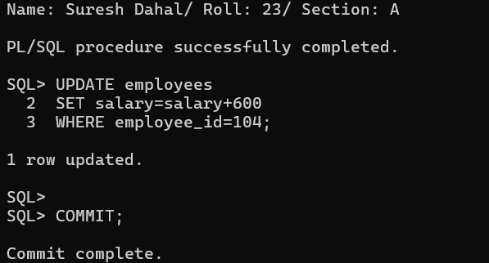
Step 5
Display all versions.
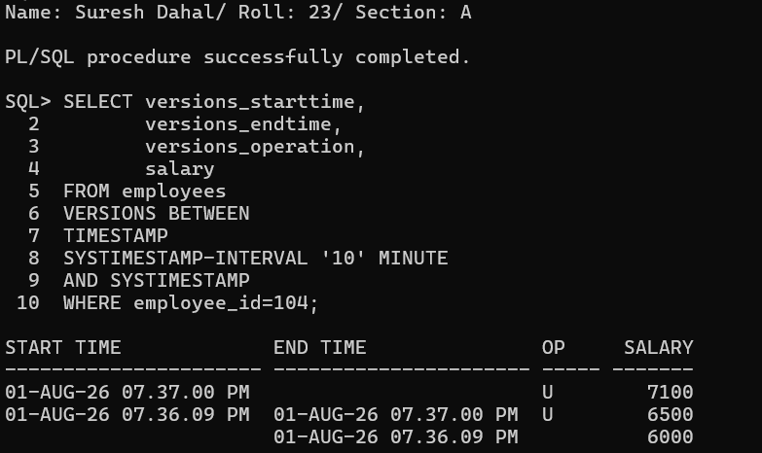

(d) Flashback Table
Step 1
Connect as sys
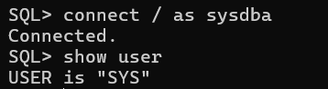
Step 2
Enable row movement.
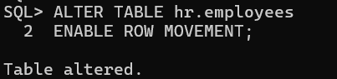
Step 3
Connect back as HR.
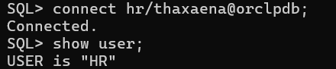

Step 4
Delete employee 105.
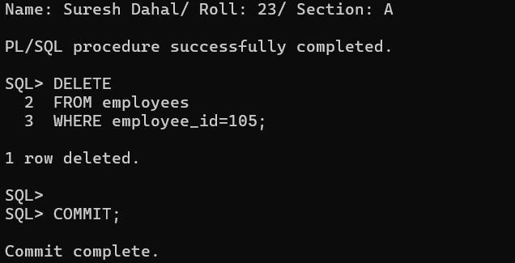
Step 5
Record timestamp.
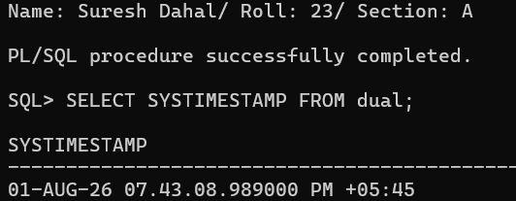
Step 6
Flashback table.
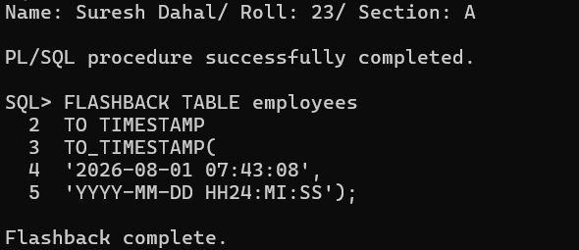
Step 7
Verify.
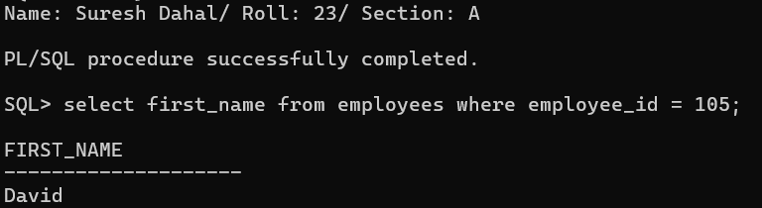

(e) Flashback Drop
Step 1
Drop table.
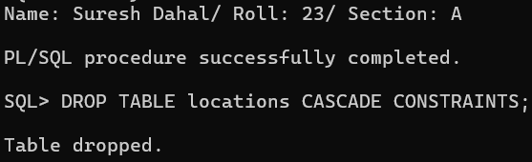
Step 2
Check recycle bin.
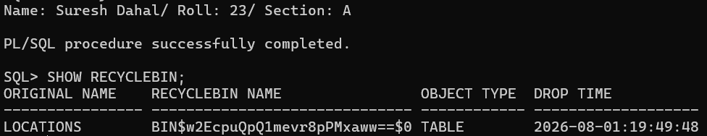
Step 3
Restore table.
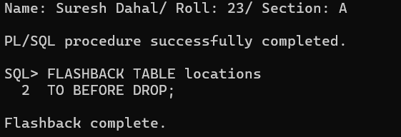
Step 4
Verify.
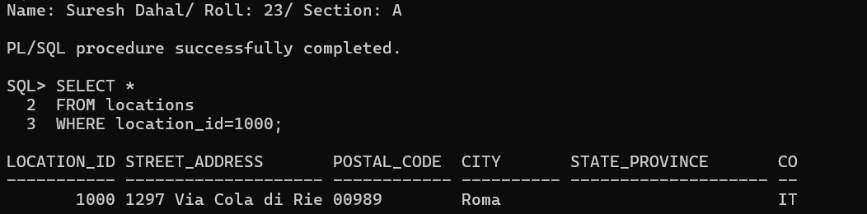
(f) Validation and Cleanup
Restore employee 103 salary
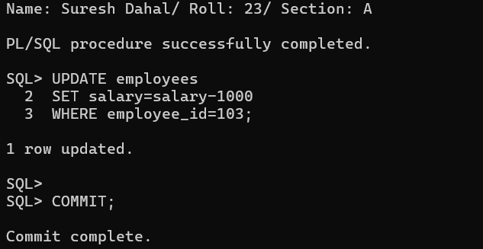
Restore employee 104 salary
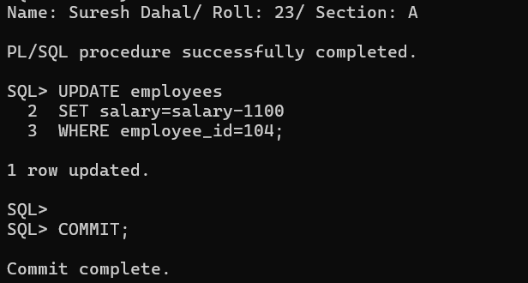
Delete employee 105 again
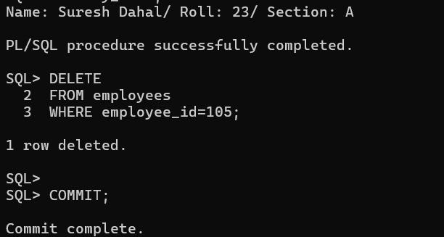
Demonstrating ORA-08180
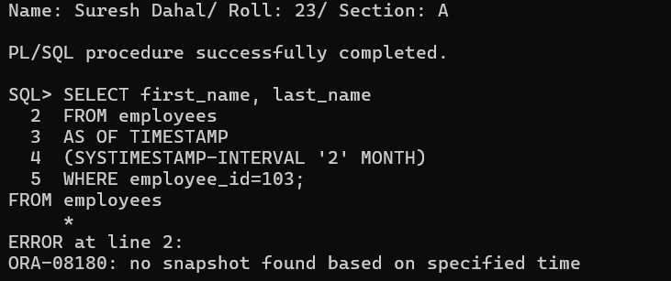

15. ORACLE FLASHBACK VERSION QUERY AND TRANSACTION QUERY
THEORY
Oracle Flashback Technology provides mechanisms to view and recover historical data without restoring database backups. It uses information stored in the UNDO tablespace to reconstruct previous versions of rows and transactions. Flashback features are useful for recovering from accidental changes, auditing modifications, and analyzing data history.
Flashback Version Query displays every version of a row that existed within a specified time interval. It provides information such as when each version became active, the operation performed (Insert, Update, or Delete), the transaction ID (XID), and the values stored in each version. This feature is commonly used for auditing and tracking changes.
Flashback Transaction Query retrieves information about committed transactions from the FLASHBACK_TRANSACTION_QUERY view. It displays details such as the transaction ID, affected table, operation performed, commit timestamp, and automatically generated UNDO_SQL statements that can be executed to reverse the transaction.
The UNDO_RETENTION parameter determines how long Oracle attempts to retain undo information. Flashback features depend on the availability of this undo data. If the required undo information is no longer available, Oracle may return errors such as ORA-08180 or ORA-01555.

STEPS and COMMANDS
(a) Preparation and Configuration
Step 1: Connect as SYSDBA
CONNECT / AS SYSDBA;
Step 2: Grant required privileges to HR
GRANT SELECT ANY TRANSACTION TO hr;

GRANT FLASHBACK ANY TABLE TO hr;

GRANT SELECT ON v_$transaction TO hr;
Step 3: Check UNDO retention
SHOW PARAMETER undo_retention;
Step 4: Increase UNDO retention (if less than 7200)
ALTER SYSTEM SET undo_retention=7200;
Step 5: Verify the parameter
SHOW PARAMETER undo_retention;

(b) Flashback Version Query Setup and Execution
Step 1: Connect as HR
CONNECT hr/thaxaena;
Step 2: View current salary
SELECT employee_id,
salary
FROM employees
WHERE employee_id=106;
Step 3: First update
UPDATE employees
SET salary=salary+1000
WHERE employee_id=106;

COMMIT;
Wait approximately 1 minute.
Step 4: Second update
UPDATE employees
SET salary=salary+500
WHERE employee_id=106;

COMMIT;
Wait approximately 1 minute.
Step 5: Delete the row
DELETE
FROM employees
WHERE employee_id=106;

COMMIT;
Step 6: Display all versions
SELECT
versions_starttime,
versions_operation,
versions_xid,
salary
FROM employees
VERSIONS BETWEEN TIMESTAMP
SYSTIMESTAMP-INTERVAL '15' MINUTE
AND SYSTIMESTAMP
WHERE employee_id=106;
Explanation
- VERSIONS_STARTTIME shows when a row version became active.
- VERSIONS_OPERATION indicates the operation performed:
  - U = Update
  - D = Delete
  - I = Insert
- VERSIONS_XID is the transaction identifier associated with each version.
- SALARY shows the salary value for each historical version.

(c) Analysis of Version Query Results
Step 1: Identify the transaction ID
From the Version Query output, note the VERSIONS_XID corresponding to the delete operation.
Step 2: Restore the deleted row
INSERT INTO employees
SELECT *
FROM employees
AS OF TIMESTAMP
(
SYSTIMESTAMP-INTERVAL '5' MINUTE
)
WHERE employee_id=106;

COMMIT;
Step 3: Verify restoration
SELECT *
FROM employees
WHERE employee_id=106;
Discussion
Flashback Version Query enables users to view previous versions of data without maintaining manual audit tables or logs. It simplifies auditing by showing when changes occurred, the type of operation performed, and the transaction responsible for the modification.

(d) Flashback Transaction Query Setup and Execution
Step 1: Perform a transaction
UPDATE employees
SET salary=salary+1000
WHERE employee_id=107;

DELETE
FROM employees
WHERE employee_id=206;
Step 2: Obtain the transaction ID before committing
SELECT RAWTOHEX(xid) AS xid
FROM v$transaction;
Record the XID displayed.
Step 3: Commit the transaction
COMMIT;
Step 4: Query Flashback Transaction Query
Replace PASTE_XID_HERE with the recorded XID.
SELECT
operation,
table_name,
undo_sql
FROM flashback_transaction_query
WHERE xid=HEXTORAW(' 08001B00A8020000');

(e) Reversing Changes with Transaction Query
Execute the generated UNDO_SQL statements returned by the previous query.
Example:
INSERT INTO employees(...);

UPDATE employees
SET ...
WHERE ...;
Verify the changes
SELECT *
FROM employees
WHERE employee_id IN (107,108);
Explanation
UNDO_SQL contains SQL statements automatically generated by Oracle to reverse the original transaction. Executing these statements restores the data to its previous state. If undo information has expired, Oracle may be unable to reconstruct the required historical data and Flashback operations may fail.

(f) Validation and Advanced Scenario
Step 1: Attempt a Version Query beyond available undo history
SELECT *
FROM employees
AS OF TIMESTAMP
(
SYSTIMESTAMP-INTERVAL '2' MONTH
)
WHERE employee_id=106;
Oracle may return either:
ORA-08180: no snapshot found based on specified time
or
ORA-01555: snapshot too old
depending on the availability of undo information.
Step 2: Perform a larger transaction
UPDATE employees
SET salary=salary+500
WHERE employee_id=109;

UPDATE departments
SET manager_id=200
WHERE department_id=20;
Step 3: Obtain the transaction ID
SELECT RAWTOHEX(xid) AS xid
FROM v$transaction;
Step 4: Commit
COMMIT;
Step 5: Query transaction information
SELECT
operation,
table_name,
undo_sql
FROM flashback_transaction_query
WHERE xid=HEXTORAW(' 0A001000B7050000');
Step 6: Execute the generated UNDO_SQL statements
Execute the SQL statements returned by the query.
Step 7: Verify
SELECT employee_id,
salary
FROM employees
WHERE employee_id=109;

SELECT department_id,
manager_id
FROM departments
WHERE department_id=20;

OUTPUT
(a) Preparation and Configuration
Step 1: Connect as SYSDBA
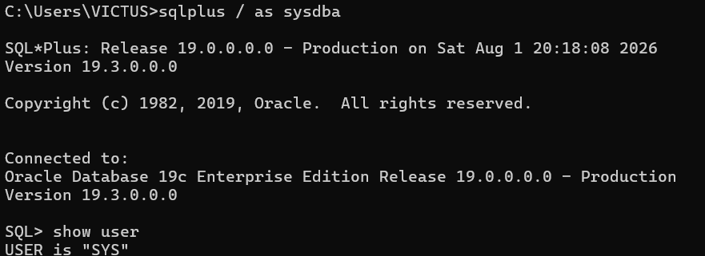Step 2: Grant required privileges to HR
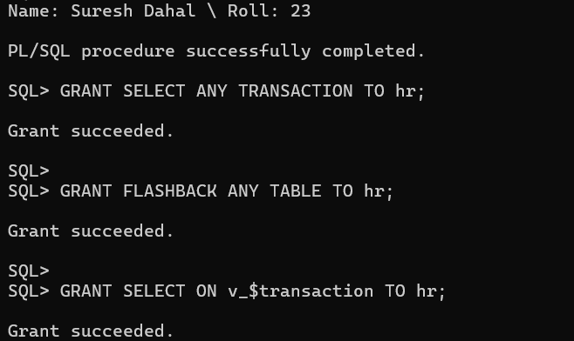
Step 3: Check UNDO retention
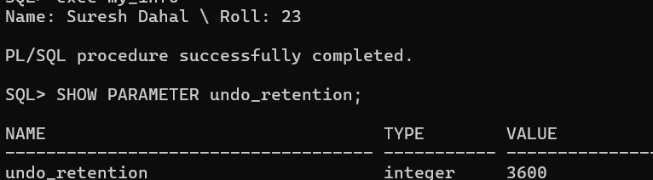Step 4: Increase UNDO retention (if less than 7200)
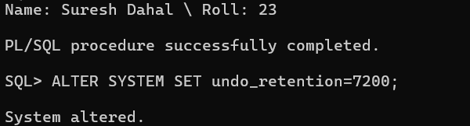
Step 5: Verify the parameter
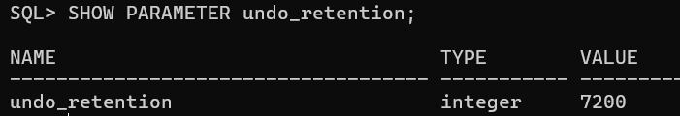
(b) Flashback Version Query Setup and Execution
Step 1: Connect as HR
Step 2: View current salary
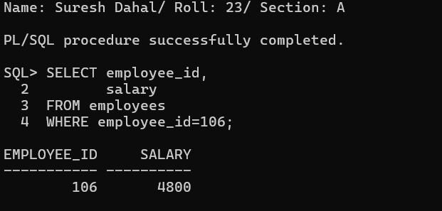
Step 3: First update
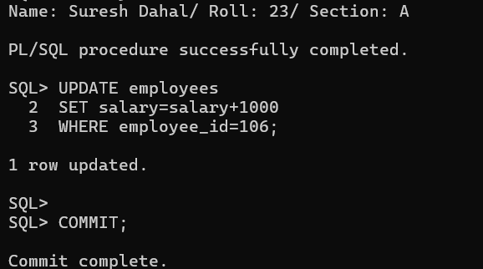
Step 4: Second update
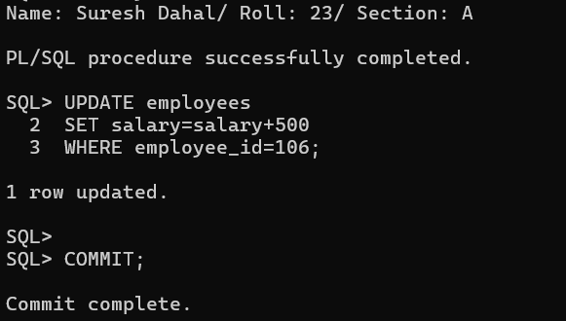
Step 5: Delete the row
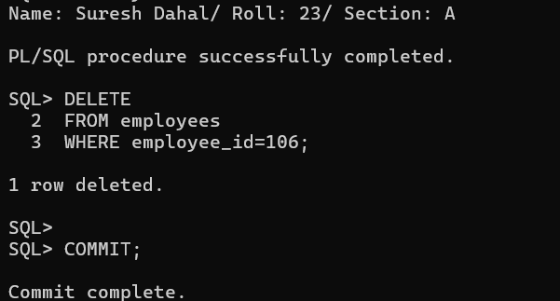
Step 6: Display all versions
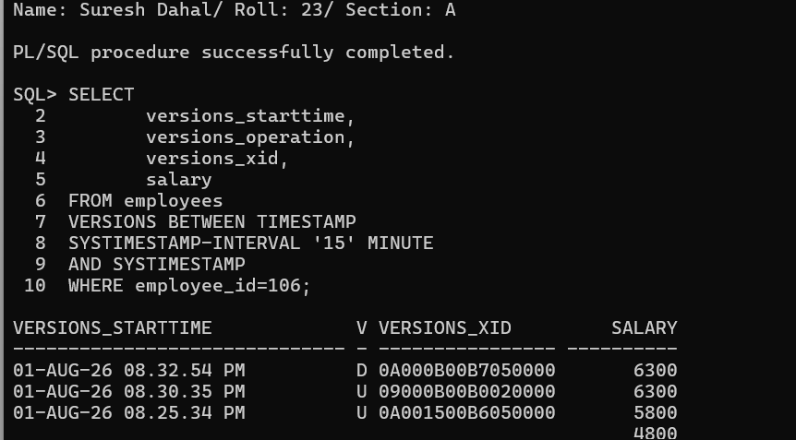

(c) Analysis of Version Query Results
Step 1: Identify the transaction ID
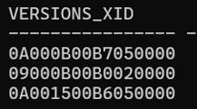
Step 2: Restore the deleted row
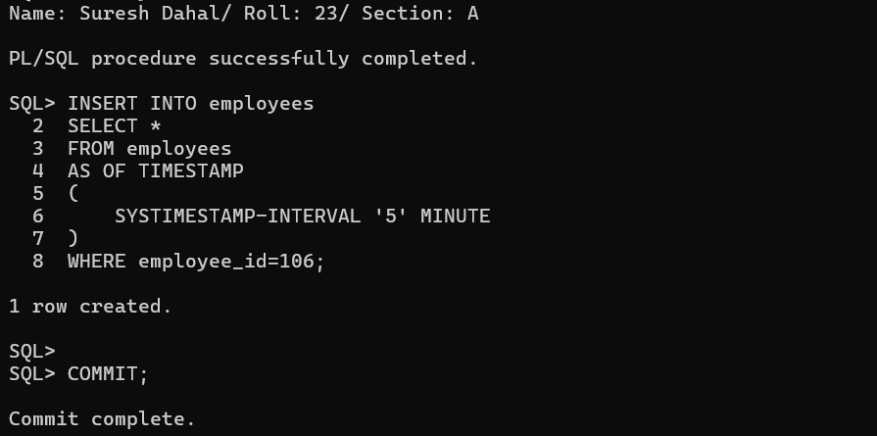Step 3: Verify restoration
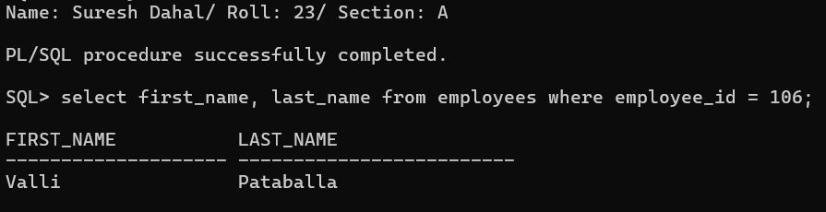

(d) Flashback Transaction Query Setup and Execution
Step 1: Perform a transaction
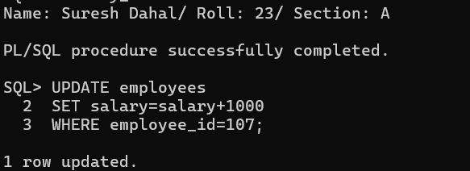
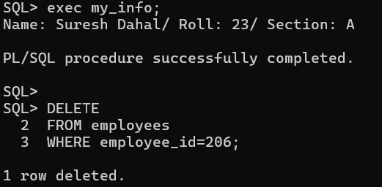
Step 2: Obtain the transaction ID before committing
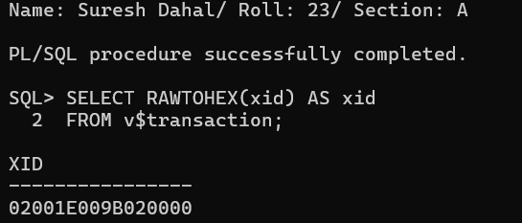
Step 3: Commit the transaction
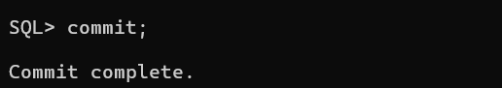
Step 4: Query Flashback Transaction Query
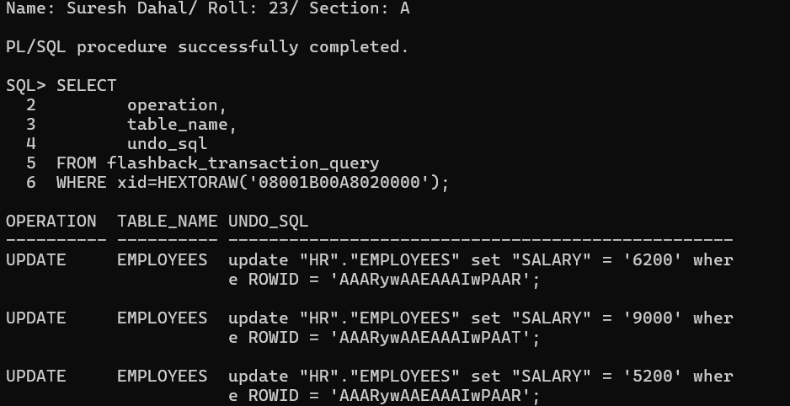
(e) Reversing Changes with Transaction Query
Execute the generated UNDO_SQL statements returned by the previous query.
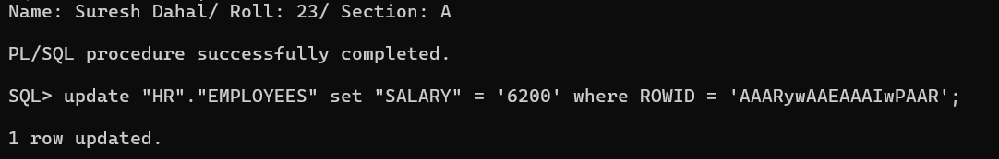
Verify the changes
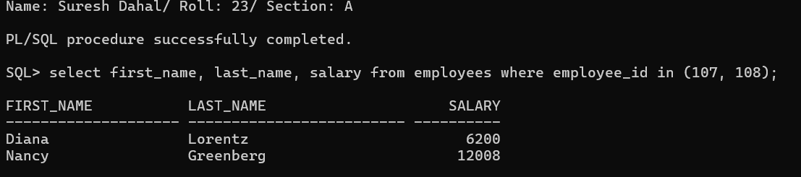
(f) Validation and Advanced Scenario
Step 1: Attempt a Version Query beyond available undo history
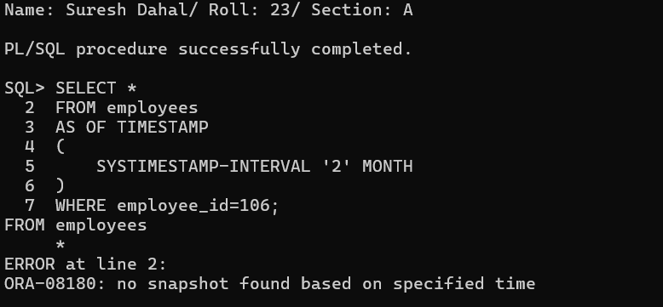
Step 2: Perform a larger transaction
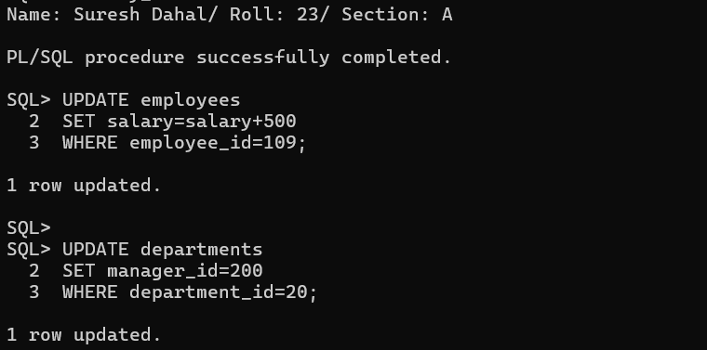Step 3: Obtain the transaction ID
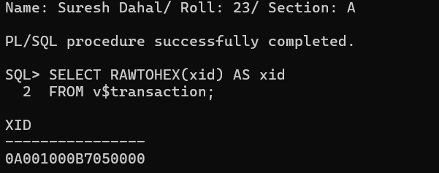
Step 4: Commit
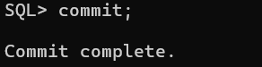
Step 5: Query transaction information
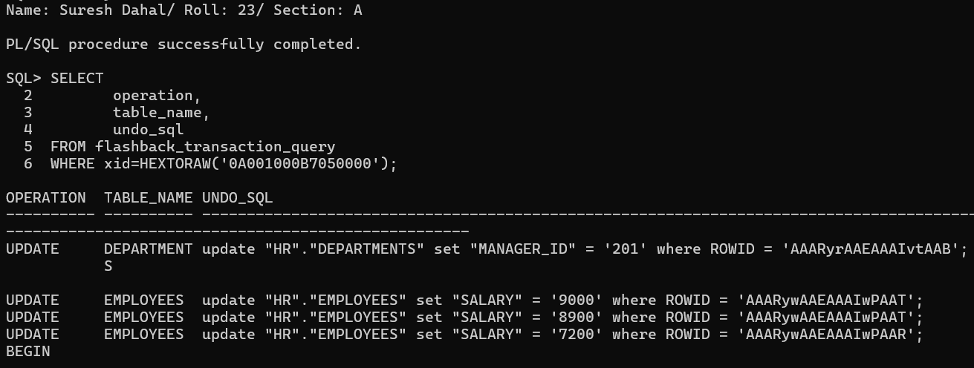Step 6: Execute the generated UNDO_SQL statements
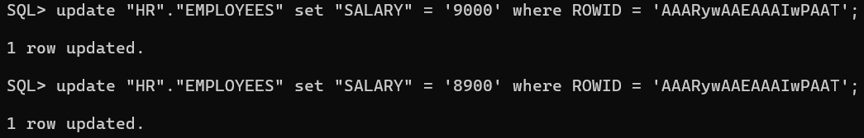
Step 7: Verify
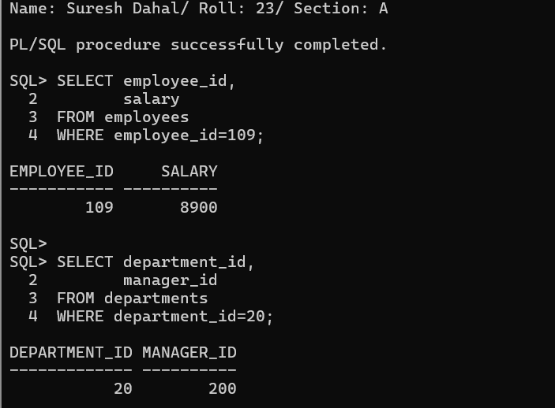
16. AUTOMATIC WORKLOAD REPOSITORY (AWR) IN ORACLE 19C
THEORY
Automatic Workload Repository (AWR) is a built-in Oracle performance monitoring and diagnostic tool that automatically collects, processes, and stores database performance statistics at regular intervals. It captures information such as CPU usage, wait events, SQL execution statistics, memory utilization, and system activity. AWR data helps database administrators analyze workload, identify performance bottlenecks, and optimize database performance.
AWR stores performance snapshots in the SYSAUX tablespace. These snapshots can be created automatically or manually. By comparing two snapshots, Oracle generates an AWR report that summarizes database performance during the selected time interval.
Important AWR parameters include:
- STATISTICS_LEVEL – Determines the level of statistics collection. It should be set to TYPICAL or ALL for AWR to function properly.
- CONTROL_MANAGEMENT_PACK_ACCESS – Enables Diagnostic and Tuning Packs. It should be set to DIAGNOSTIC+TUNING.
- Snapshot Interval – Specifies how frequently Oracle automatically creates AWR snapshots.
AWR reports contain useful sections such as Report Summary, Load Profile, Instance Efficiency Percentages, Top Timed Foreground Events, SQL Statistics, and Advisory Sections, which help identify inefficient SQL statements and system bottlenecks.

STEPS and COMMANDS
(a) Preparation and Configuration
Step 1: Connect to Oracle as SYSDBA
Open SQL*Plus and connect as SYSDBA.
CONNECT / AS SYSDBA;
Take a screenshot after successful login.

Step 2: Verify AWR parameters
Execute the following query to check whether AWR is properly configured.
SELECT name, value
FROM v$parameter
WHERE name IN
('statistics_level',
'control_management_pack_access');
Verify that:
- STATISTICS_LEVEL = TYPICAL
- CONTROL_MANAGEMENT_PACK_ACCESS = DIAGNOSTIC+TUNING
Take a screenshot of the output.

Step 3: Modify parameters (only if required)
If any parameter is different, execute the appropriate command.
ALTER SYSTEM SET statistics_level='TYPICAL';

ALTER SYSTEM SET control_management_pack_access='DIAGNOSTIC+TUNING';
Run the query from Step 2 again to verify the changes.

Step 4: Check the default snapshot interval
Execute:
SELECT
extract(day FROM snap_interval)*24*60+
extract(hour FROM snap_interval)*60+
extract(minute FROM snap_interval)
AS snapshot_interval
FROM dba_hist_wr_control;
The default snapshot interval is usually 60 minutes.
Take a screenshot of the result.

(b) Create Baselines with Snapshots
Step 1: Create the first AWR snapshot
While connected as SYSDBA, create a manual snapshot.
EXEC DBMS_WORKLOAD_REPOSITORY.CREATE_SNAPSHOT;
Take a screenshot showing that the snapshot was created successfully.

Step 2: Connect as HR
Switch to the HR user.
CONNECT hr/hr;

Step 3: Generate workload
Execute the following SQL queries one after another.
SELECT e.employee_id,
e.first_name,
d.department_name
FROM employees e
JOIN departments d
ON e.department_id=d.department_id;
SELECT d.department_name,
COUNT(*)
FROM employees e
JOIN departments d
ON e.department_id=d.department_id
GROUP BY d.department_name;
SELECT employee_id,
first_name,
salary
FROM employees
WHERE salary >
(
SELECT AVG(salary)
FROM employees
);
SELECT department_id,
AVG(salary)
FROM employees
GROUP BY department_id;
SELECT *
FROM employees
ORDER BY salary DESC;
Next, execute the following update statement.
UPDATE employees
SET salary = salary + 100
WHERE employee_id = 101;

COMMIT;
Restore the original salary.
UPDATE employees
SET salary = salary - 100
WHERE employee_id = 101;

COMMIT;
Run the SELECT statements again 2–3 times to generate additional database activity.
Take screenshots while executing the workload.

Step 4: Create the second snapshot
Reconnect as SYSDBA.
CONNECT / AS SYSDBA;
Create another snapshot.
EXEC DBMS_WORKLOAD_REPOSITORY.CREATE_SNAPSHOT;
Take a screenshot.

Step 5: View available snapshots
Display all snapshots.
SELECT snap_id,
begin_interval_time,
end_interval_time
FROM dba_hist_snapshot
ORDER BY snap_id;
Note the two most recent SNAP_ID values because they will be used to generate the AWR report.
Take a screenshot.

(c) Generate AWR Report
Step 1: Run the AWR report script
While connected as SYSDBA, execute:
@?/rdbms/admin/awrrpt.sql
Oracle will ask several questions.

Step 2: Select report type
When prompted:
Specify the Report Type
Enter
html

Step 3: Specify the number of days
When prompted:
Specify the number of days of snapshots
Enter
1

Step 4: Enter Begin Snapshot ID
When prompted:
Enter value for begin_snap:
Enter the first SNAP_ID noted earlier.
Example:
150

Step 5: Enter End Snapshot ID
When prompted:
Enter value for end_snap:
Enter the second SNAP_ID.
Example:
151

Step 6: Specify the report name
When prompted:
Enter value for report_name:
Enter
awr_report.html
Oracle will generate the report and display a completion message similar to:
Report written to awr_report.html
Take a screenshot.

Step 7: Open the generated report
Open awr_report.html using any web browser.

(d) Analysis of AWR Report Sections
1. Instance Efficiency Percentages
- Buffer Hit % = 99.75%, indicating efficient use of the buffer cache with very little disk I/O.
- Parse CPU to Parse Elapsed % = 78.13%, indicating SQL parsing was reasonably efficient.
- Library Hit % = 88.47%, showing most SQL statements reused existing execution plans.
2. Top Timed Foreground Events
- The highest wait event was Failed Logon Delay (66.6%), followed by DB CPU (30.5%).
- Disk I/O wait events were very low, indicating no major storage bottlenecks.
3. SQL Statistics
The SQL Statistics section shows that the top SQL statements were Oracle internal SQL and PL/SQL statements, such as DBMS_WORKLOAD_REPOSITORY and DBMS_AUTO_REPORT_INTERNAL, executed during snapshot creation and report generation. These SQL statements contributed approximately 49.2% of the database activity, while PL/SQL contributed about 50.3%.
4. Performance Analysis and Optimization
The AWR report shows a Buffer Hit Ratio of 99.75%, indicating efficient memory usage with very low disk I/O. However, the Library Hit Ratio (88.47%) and Execute to Parse Ratio (61.37%) suggest that SQL statements could be reused more efficiently. Performance can be improved by using bind variables, reducing unnecessary parsing, and optimizing frequently executed SQL statements.

OUTPUT
(a) Preparation and Configuration
Step 1: Connect to Oracle as SYSDBA
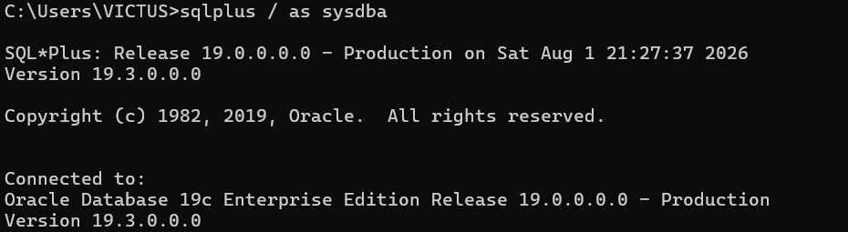
Step 2: Verify AWR parameters
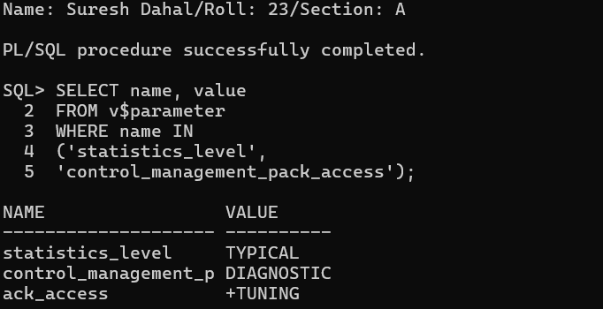

Step 3: Modify parameters
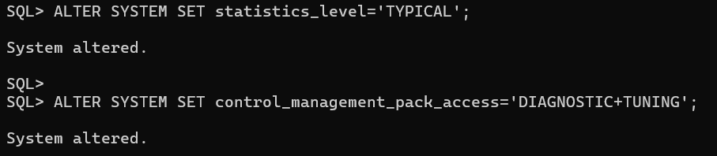
Step 4: Check the default snapshot interval
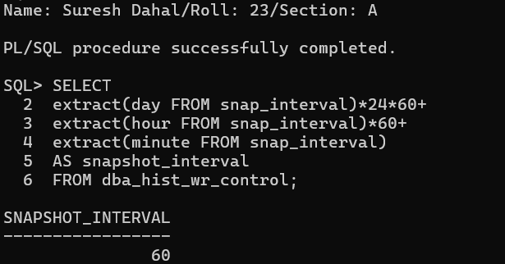
(b) Create Baselines with Snapshots
Step 1: Create the first AWR snapshot
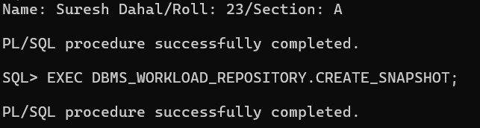
Step 2: Connect as HR
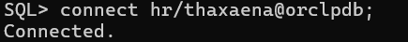
Step 3: Generate workload
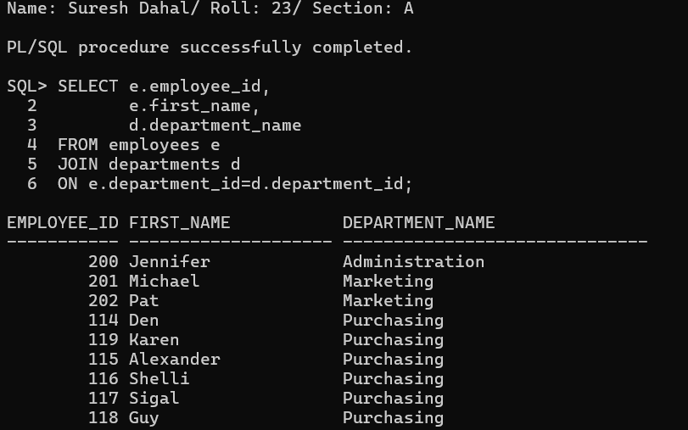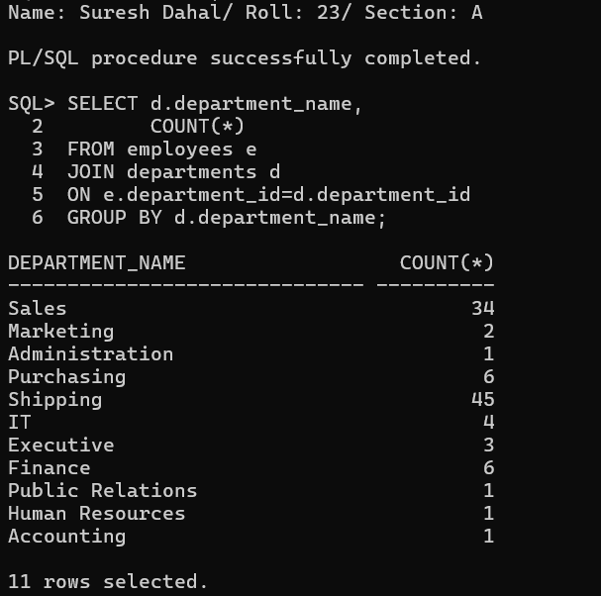
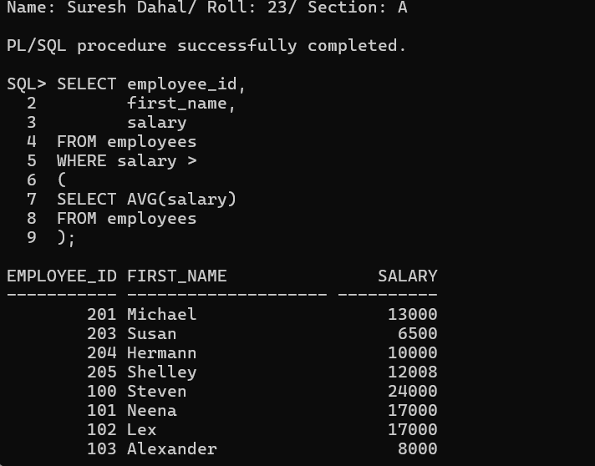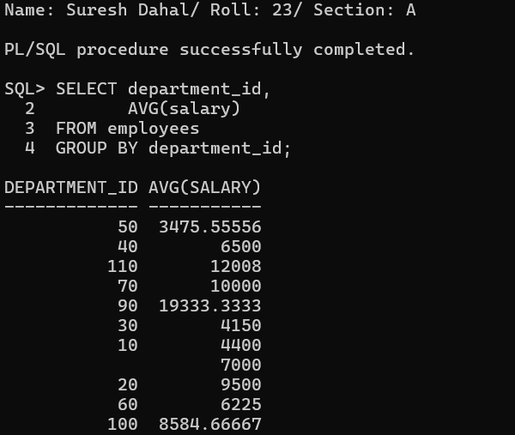
Next, execute the following update statement.
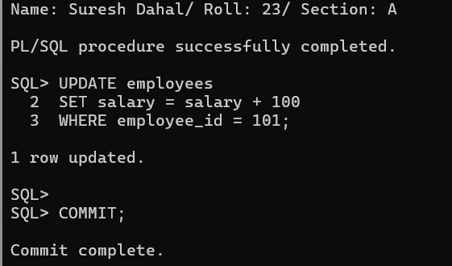
Restore the original salary.
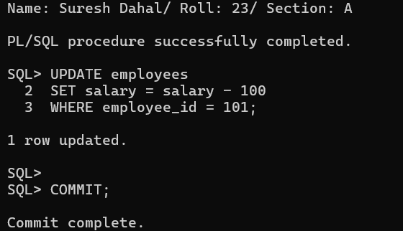

Step 4: Create the second snapshot
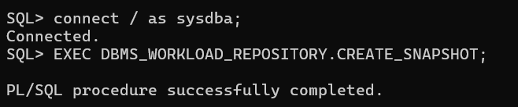
Step 5: View available snapshots
Display all snapshots.
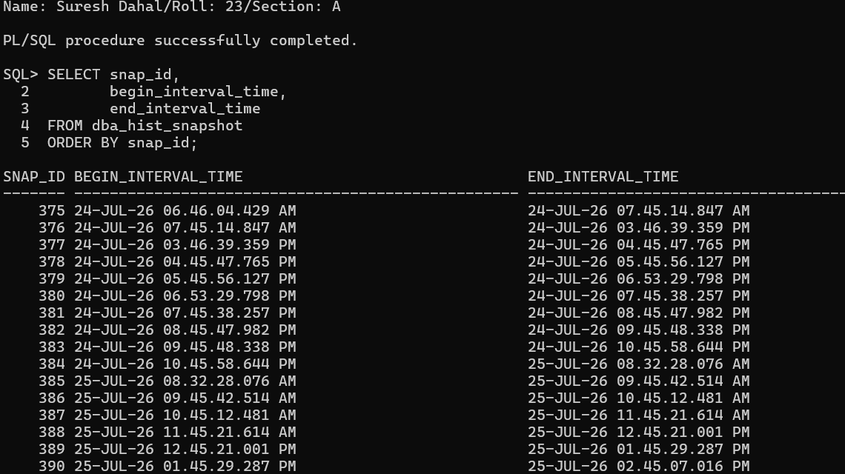
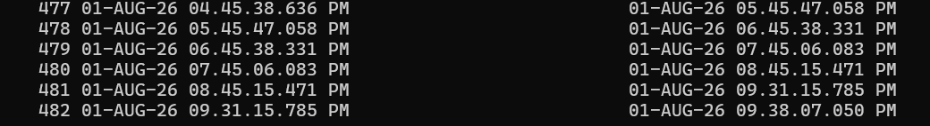

(c) Generate AWR Report
Step 1: Run the AWR report script
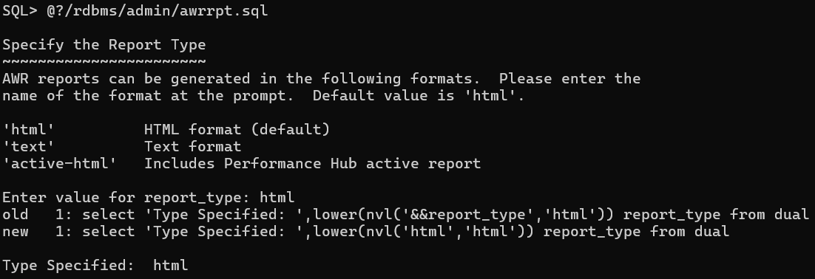
Step 2: Select report type
Step 3: Specify the number of days
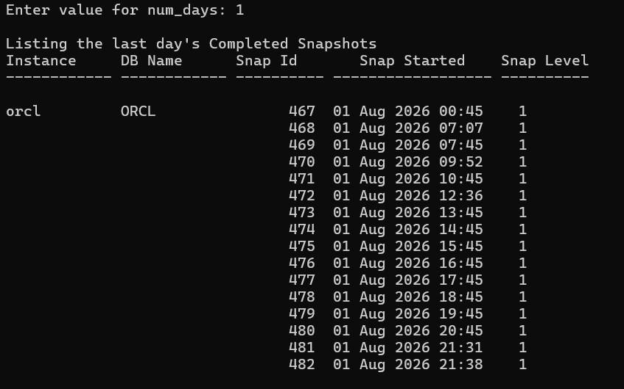
Step 4: Enter Begin Snapshot ID
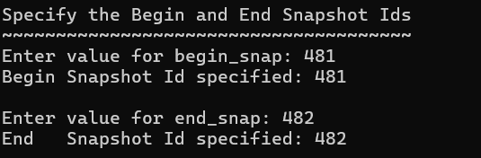
Step 5: Enter End Snapshot ID
Step 6: Specify the report name
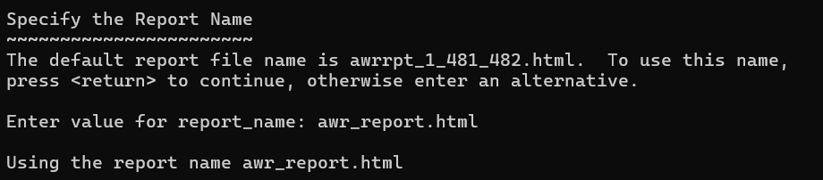
Step 7: Open the generated report
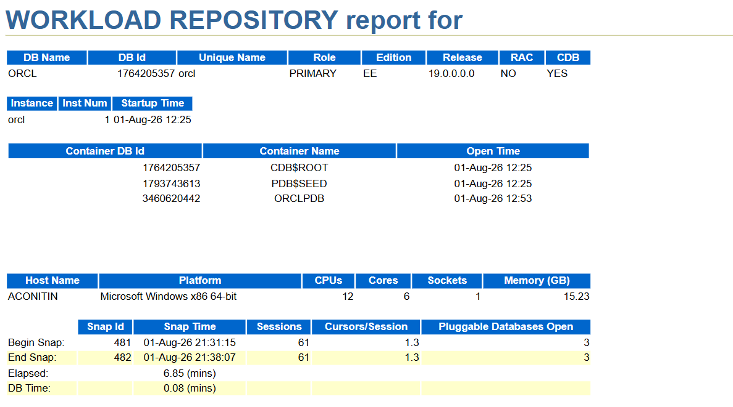
(d) Analysis of AWR Report Sections
1. Instance Efficiency Percentages
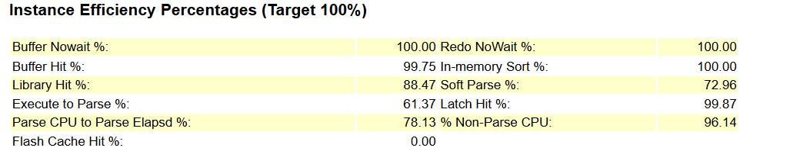
2. Top Timed Foreground Events
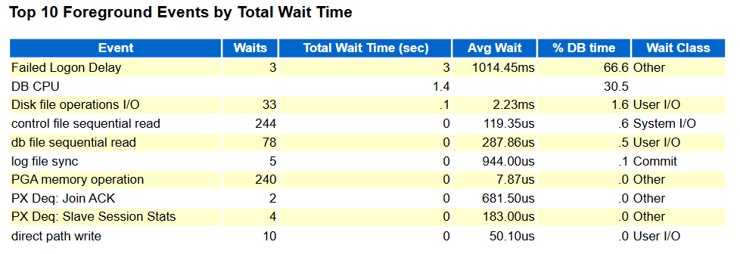
3. SQL Statistics
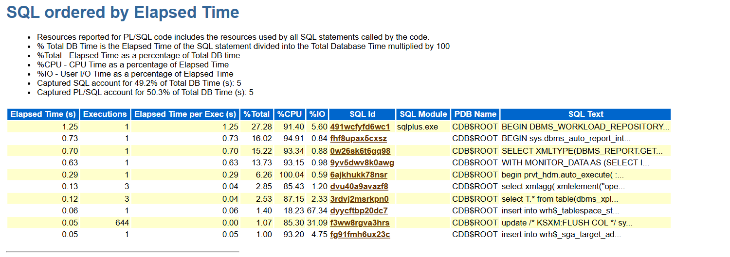4. Performance Analysis and Optimization
